**Continued Fractions: How to understand self similar and infinite processes**

**Thesis:**

Take the most dreaded middle school math and combine it with high school’s least understood concept. The infinite continued fraction is the result of placing fractions within fractions indefinitely. These fractions make appearances in math contests to highlight tricks for manipulating self-similar, infinite processes. However, these tricks make problematic assumptions that can lead to paradoxes. This talk will use continued fractions to highlight the non-intuitive nature of self-similar, infinite processes. A motivated method to approach these processes is provided. The talk includes recursive definitions of these processes and epsilon-delta style proofs. The talk ends by introducing continued fractions as an analytical theory and some interesting theorems are discussed.

Imagine taking a middle school kid’s worst nightmare and combining it with high school’s least understood concept. The continued fraction makes appearances in math contests to highlight tricks for manipulating self-similar, infinite processes but the tricks make assumptions that often lead to paradoxes. This talk will use continued fractions to highlight the non-intuitive nature of self-similar, infinite processes and will provide motivation and a method to approach these processes. The talk includes recursive definitions of these processes and $ε-δ$ style proofs. The talk will end by discussing continued fractions as an analytical theory in its own respect.

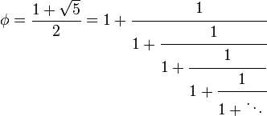Fractions within a fraction

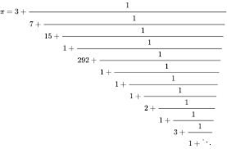

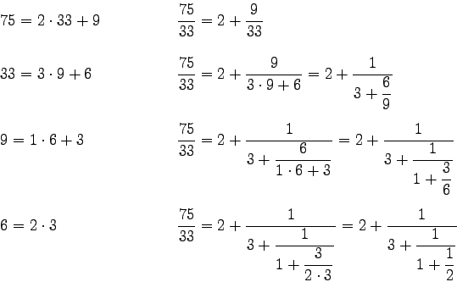Example of finite cf

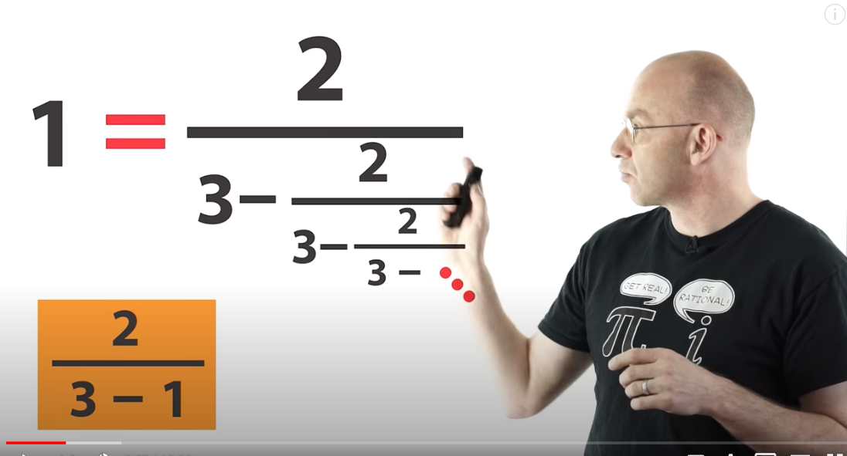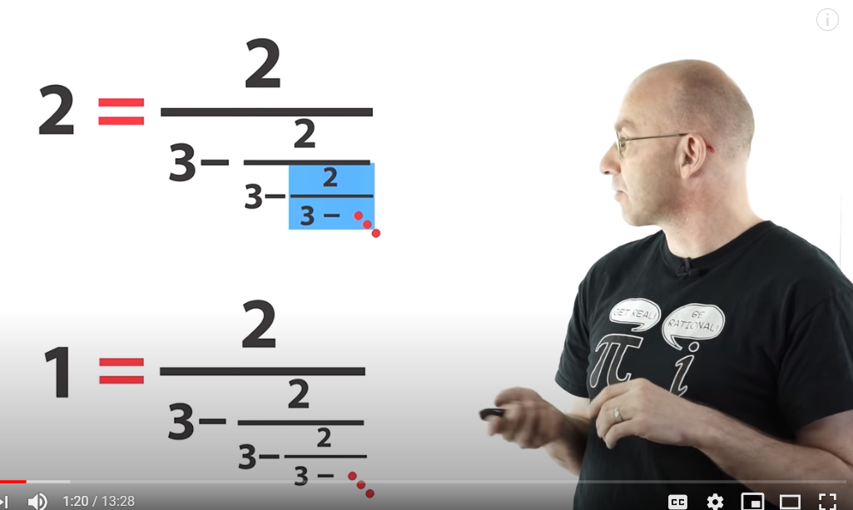

* Ratio of Fibonacci numbers tends to golden ratio
* Defining cf as linear transformations, and some theorems
* Defining iterative process and def of infinite cf, with examples and motivation
* Khinshin’s constant